THE JOY OF DETRENDING III
By
John Ehlers

There must be a jillion ways to detrend price data. Given that, I had better have an approach with significant advantages to write still another article on the subject. I believe I have such an approach and will show you its distinct advantages. One of the advantages is that a detrended signal, combined with an optimum smoothing filter can produce an awesome oscillator type indicator.

My technical analysis techniques all use the methods of modern signal analysis. This new detrending approach is borrowed from radar circuit designs. A radar works by transmitting a high power RF pulse of energy and listening for the return echoes from various targets. RF energy travels at the speed of light, and so the round trip time for an echo is 12.4 microseconds per mile. The distance of the target from the transmitter is a determined simply by measuring the time it takes for the echo to return. After sufficient time has elapsed so that no more echoes are expected, the radar transmits another pulse. The process is repetitive, and the time between repetitive transmitter pulses is called the PRI (Pulse Repetition Interval).

Targets that are a fixed distance from the radar transmitter, such as buildings and towers, always appear at the same range. Many radars, such as those used in air traffic control, only care about moving targets. The fixed-distance targets are just clutter and obscure the real targets of interest. Therefore, these radars use a circuit called MTI (Moving Target Indicator). There are several ways to implement MTI, but the simplest is to use the echo from a fixed target due to the previous pulse to cancel the echo from that same target from the current pulse. Figure 1 is a block diagram showing how this cancellation is accomplished.

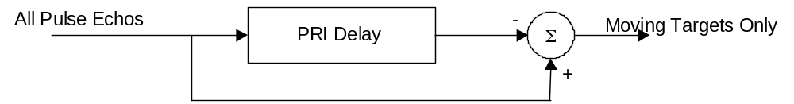

Figure 1. MTI Pulse Canceller Eliminates Fixed Targets

The delay line delays the echo from the previous pulse by exactly one PRI. Therefore pulses from fixed targets appear at the summation device at exactly the same time, and are therefore cancelled. Pulses from moving targets do not occur at exactly the same time from pulse to pulse, and are therefore not cancelled.

So how does this relate to detrending? Simple. If we subtract the price “N” bars ago from the current price, the common terms in the price are cancelled. Therefore, this “N” bar momentum function removes the static, or average, price component. Just as trends correspond to slowly moving targets on the radar scope, they tend to be removed by the “N” day momentum function. Complex price movements can be analyzed as being synthesized from a number of cyclic components, so the question really is how all these cycle components are affected by the momentum function.

Consider a 6 bar momentum function, where the price 6 bars ago is subtracted from the current price. Certainly the constant value common to both prices is removed. The longer cycle components (the trends) also tend to be removed. Shorter and shorter cycle components tend to be passed, at least until the cycle periods shorten to be approximately 6 bars. A 6 bar cycle component will be completely removed by the 6 bar momentum due to complete cancellation. Harmonics of 6 bar cycles (3 bar cycles, 1.5 bar cycles, etc.) will also be completely cancelled. Therefore, a 6 bar momentum function is not useful for waveforms having cycle periods shorter than about 10 bars. In trading daily data this is probably acceptable because we are typically not interested in cycles shorter than two weeks. The subgraph of Figure 2 shows how a 6 bar momentum function removes the constant term and gets better and better at passing the shorter cycle periods. That is, the amplitude across the spectrum is not uniform.

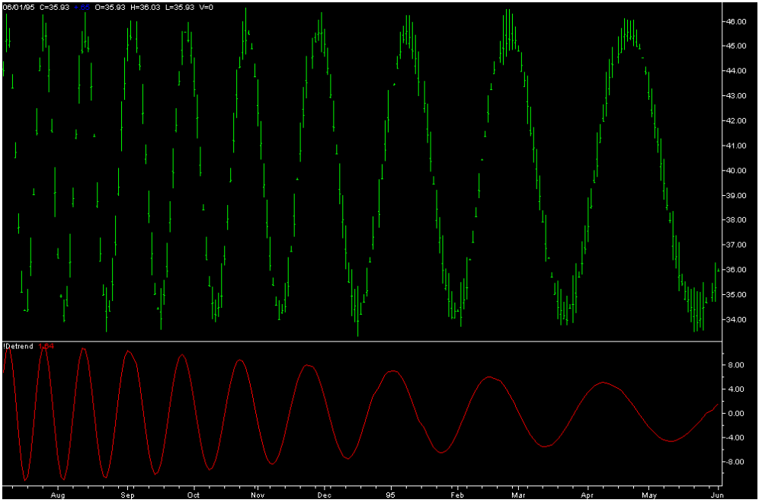

Figure 2. A 6 Bar Momentum Passes Shorter Cycles More Efficiently

Why not use a shorter momentum function, such as a 4 Bar momentum, to pass more of the shorter cycle components? The answer, as demonstrated in Figure 3, is that the longer cycle periods are passed less efficiently. The amplitude of the longer cycles undergoes greater attenuation in this case.

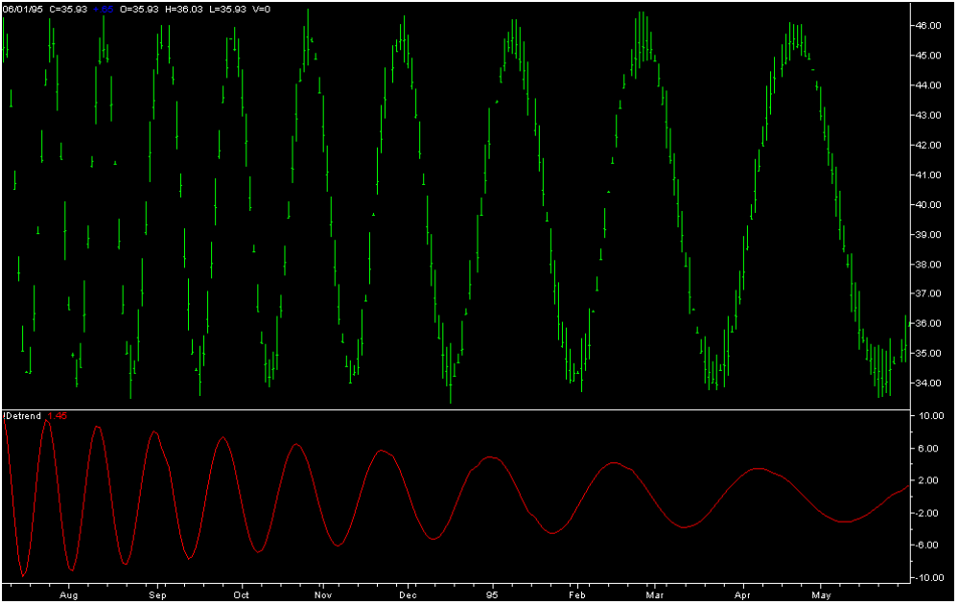

Figure 3. A 4 Bar Momentum Is Less Efficient at Passing Longer Cycles

Radars solve the problem of passing a wide range of different velocities through the MTI circuits by using more complex filters. One such circuit, shown in Figure 4, is constructed as a triple delay-line canceller.

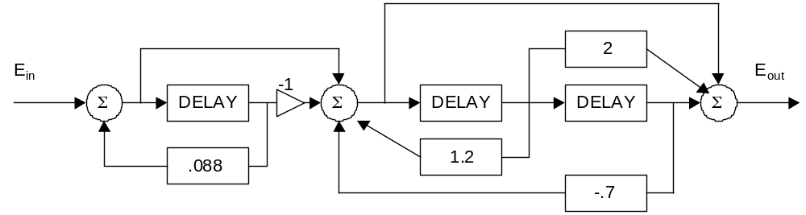

Figure 4. Triple Delay Line MTI Canceller Block Diagram

The EasyLanguage Code to implement the Triple Delay Line Canceller as a detrender is:

Inputs: Price((H+L)/2);

Vars: Detrend(0);

Value1 = Price + .088*Value1[6];
Value2 = Value1 – Value1[6] + 1.2*Value2[6] - .7*Value2[12];
Detrend = Value2[12] – 2*Value2[6] + Value2;

Plot1(Detrend, “Detrend”);

The advantage of the Triple Delay Line filter for detrending is apparent through examination of Figure 5. The detrended amplitude of all cycle components is almost the same. Therefore, the detrended waveforms retain the cyclic characteristics of the original waveforms with higher fidelity.
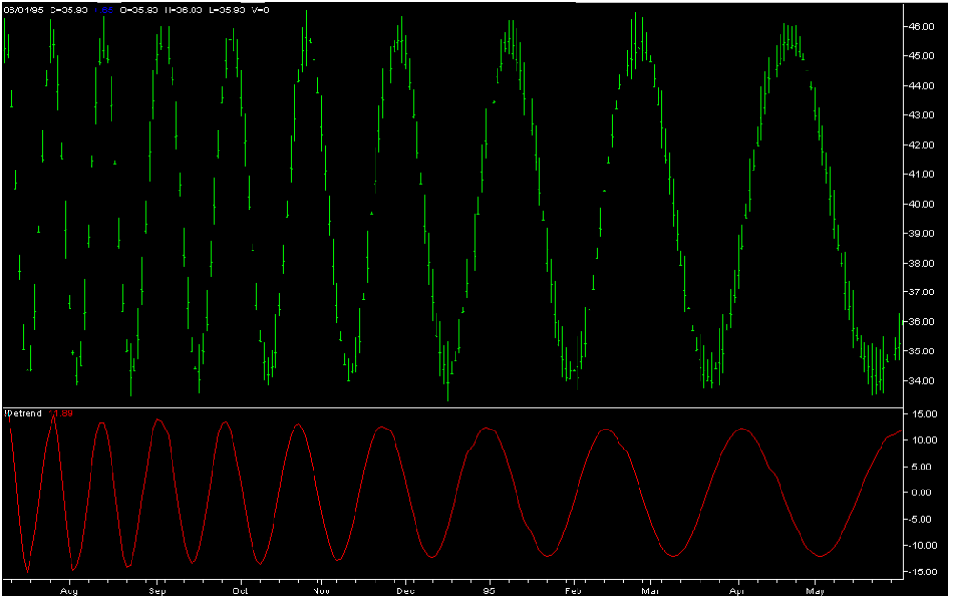

Figure 5. The Triple Delay Canceller Passes All Cycle Components of Interest

In a different vein, I have been curious about how to design an optimum smoothing filter. I set one criterion to be that the smoother could have no more than a one bar lag. An elliptic filter provides the maximum amount of smoothing under the constraint of a given lag. So, using MATLAB, I designed an elliptic filter whose performance characteristics are described in Figure 6. I set the out-of-band attenuation to be –20 dB and adjusted the in-band ripple to position the notch in the response to be exactly at .5 cycles per day (a 2 bar period). The phase delay for a frequency .125 cycles per day (an 8 bar cycle) is approximately 50 degrees. 45 degrees is one-eighth of a 360 degree full cycle, so the delay computes to be one-eighth of an 8 bar period. This shows the 1 delay will be slightly longer than the desired one bar delay.
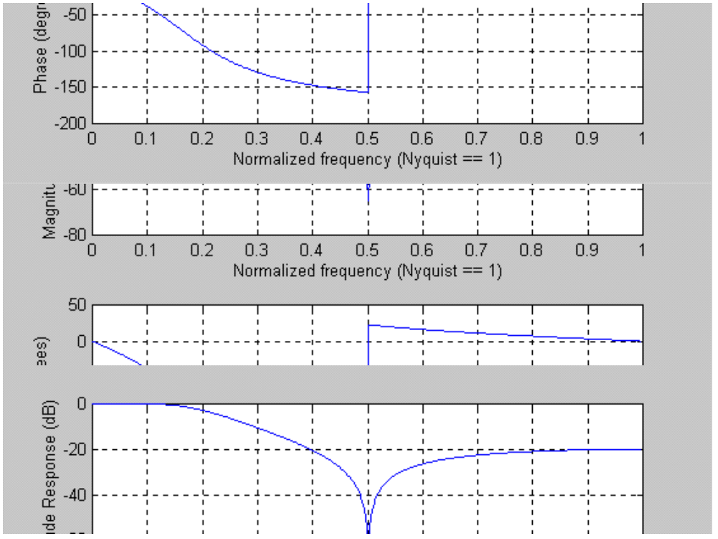

Figure 6. Response Characteristics of an Elliptic Filter having a One Bar Lag

The EasyLanguage code fragment to compute the optimum Elliptic Filter is:
Smooth = .13785*Price + .0007*Price[1] + .13785*Price[2] + 1.2103*Smooth[1] - .4867*Smooth[2]

Taking a page out of the Kalman Filtering book, I know that I can reduce the effects of lag by introducing an estimate of the velocity vector at each position. In this case, I simply add the one day momentum of the price to the price value for that bar. Doing this, the modified optimum Elliptic Filter becomes:
Smooth = .13785*(2*Price – Price[1]) + .0007*(2*Price[1] – Price[2]) + .13785*(2*Price[2] –Price[3]) + 1.2103*Smooth[1] - .4867*Smooth[2]

The Optimum Detrender and the Optimum Smoothing Filter can be used independently in a variety of applications. In addition, when they are used together, an awesome oscillator results. You know the detrender provides the maximum fidelity in the detrended waveform with regard to both phase and amplitude. The Optimum Smoother provides a minimum delay so that the crossing of the indicator lines is maximally responsive to the changing price directions. A typical example of this Awesome Oscillator is shown in Figure 7.

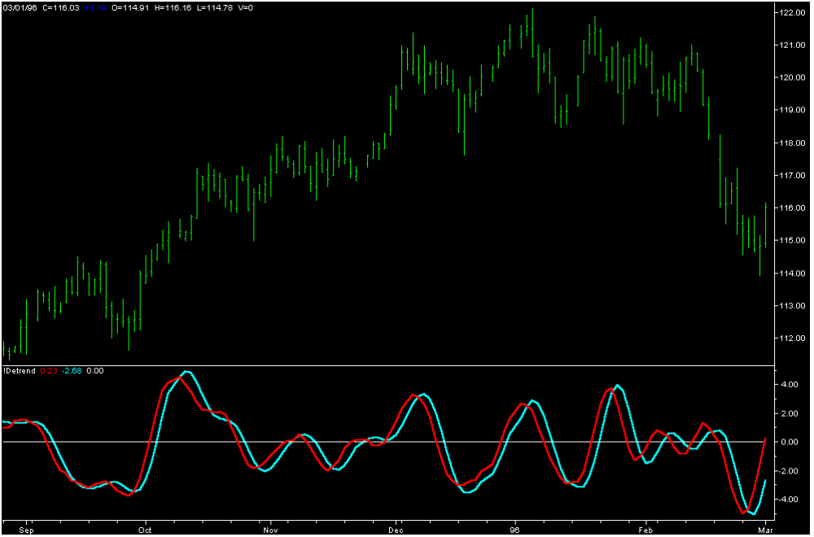

Figure 7. The Awesome Oscillator catches every cyclic turn as it happens.

The appearance of the Detrend line, in red, has been improved by smoothing with the modified optimum Elliptic Filter. The lag penalty is minimal. The smoothed Detrended signal is again smoothed with the modified optimum Elliptic filter, and is shown in cyan. The crossings of the two indicator lines accurately catches every major cyclic move. As with all oscillators, with the exception of the Sinewave Indicator, care must be taken in using the signals when the market is in a trend mode.

John Ehlers, “A Trend-Friendly Oscillator”, Stocks & Commodities, May 2000

